ASSIGINMENT 1

NAME : Muhammad Mudassir

SUBJECT : Programming Fundamentals

DATE : 17th November 2023

ROLL # : 23 – AI – 03

EXERCISE 1 : Simple Variable Assignment

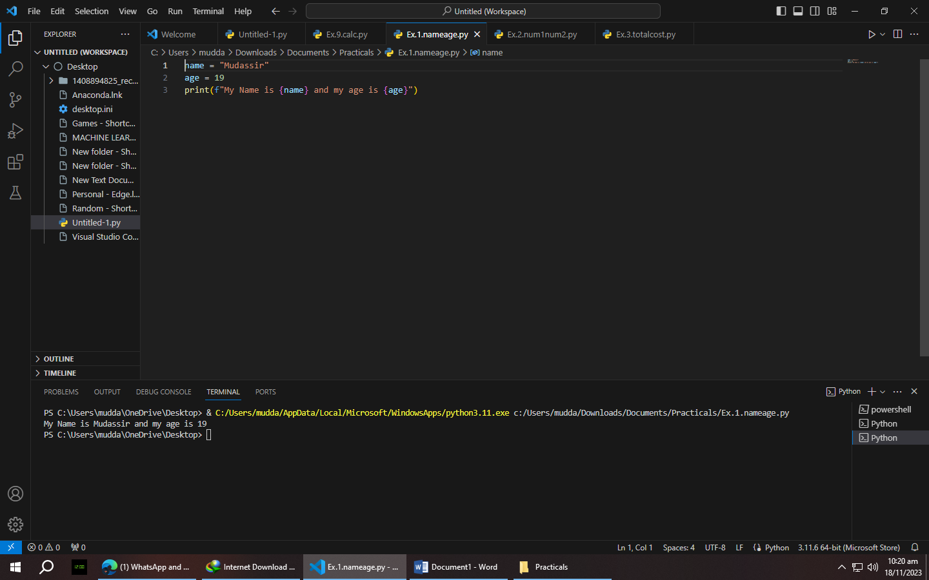

Exercise 2 : Multiple Variable Assignments

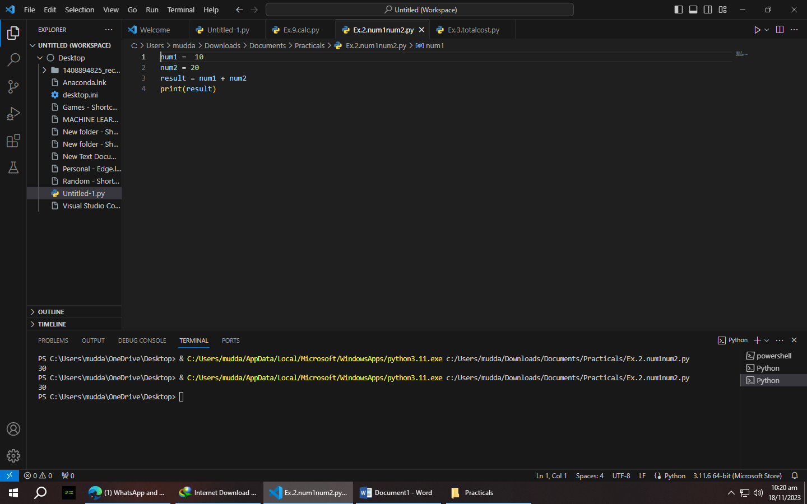

Exercise 3 : Variable Types

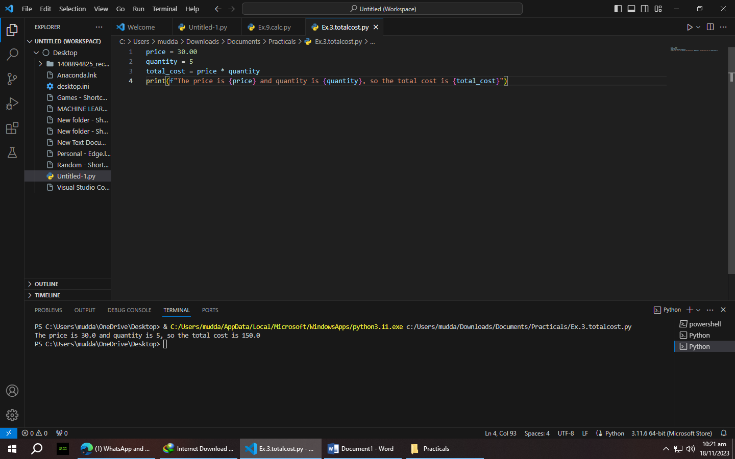

Exercise 4 : String Concatenation

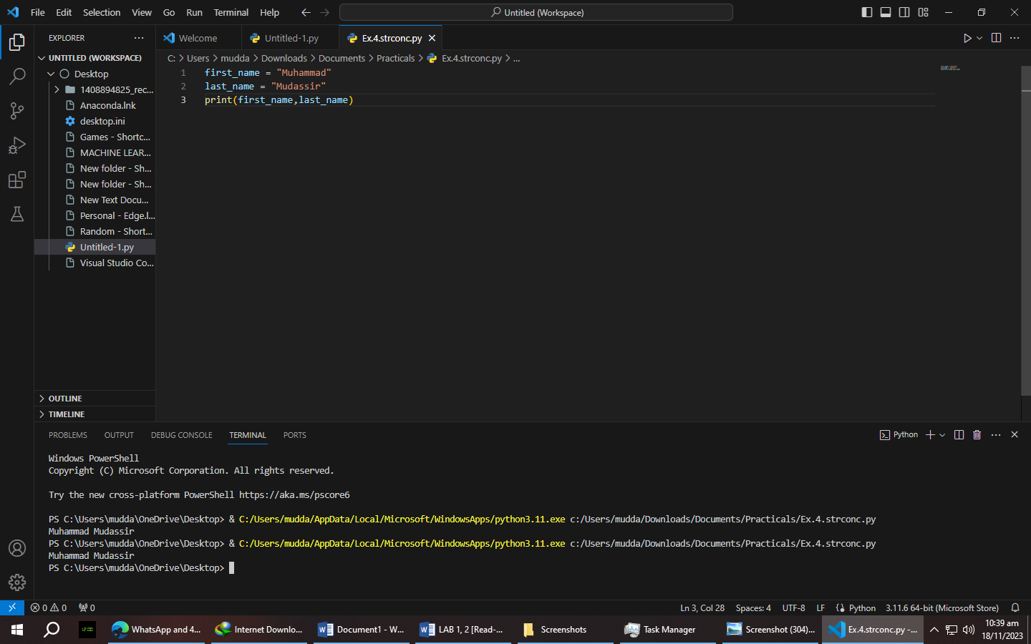

Exercise 5 : Boolean Variables

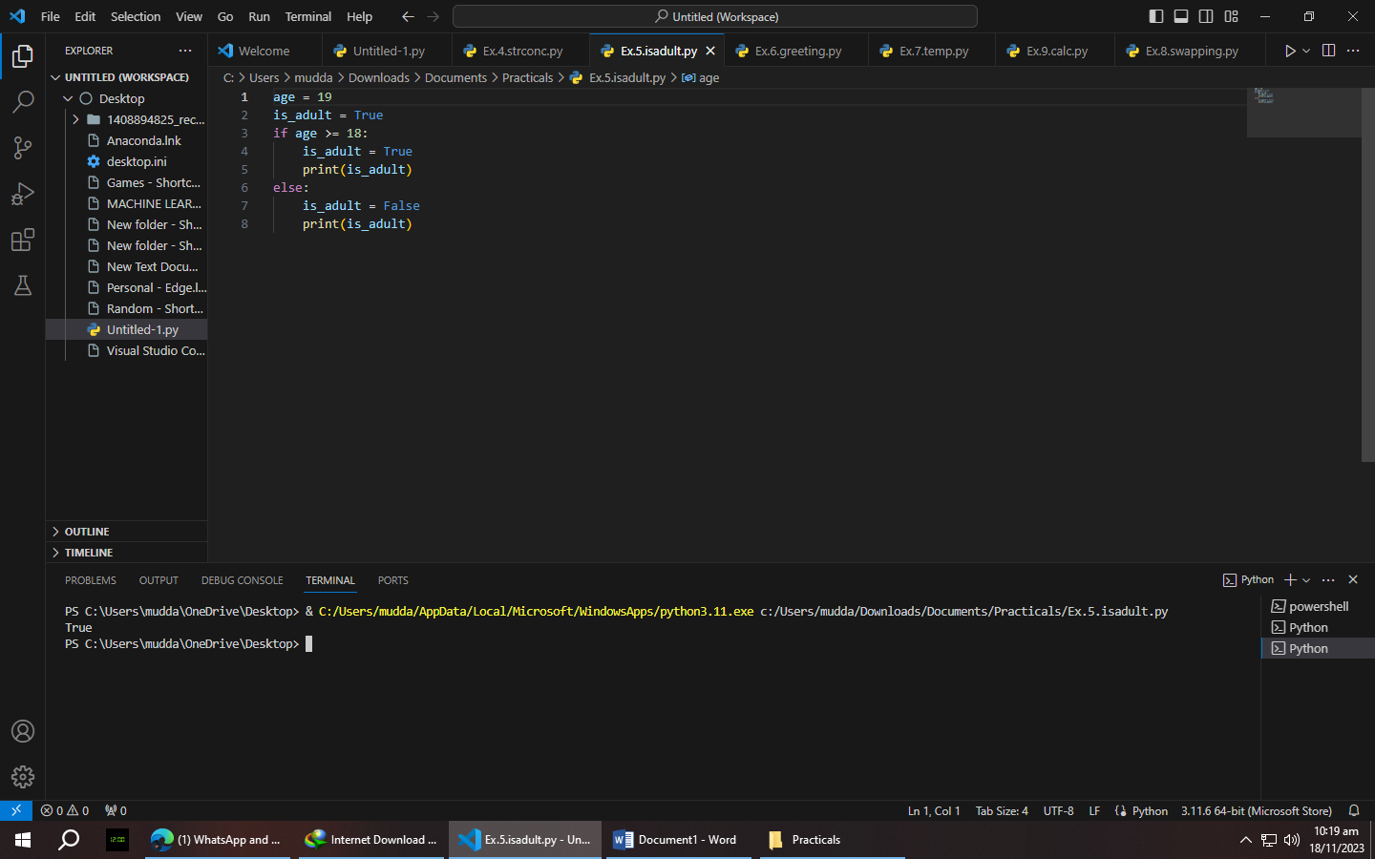

Exercise 6 : Interactive User Input

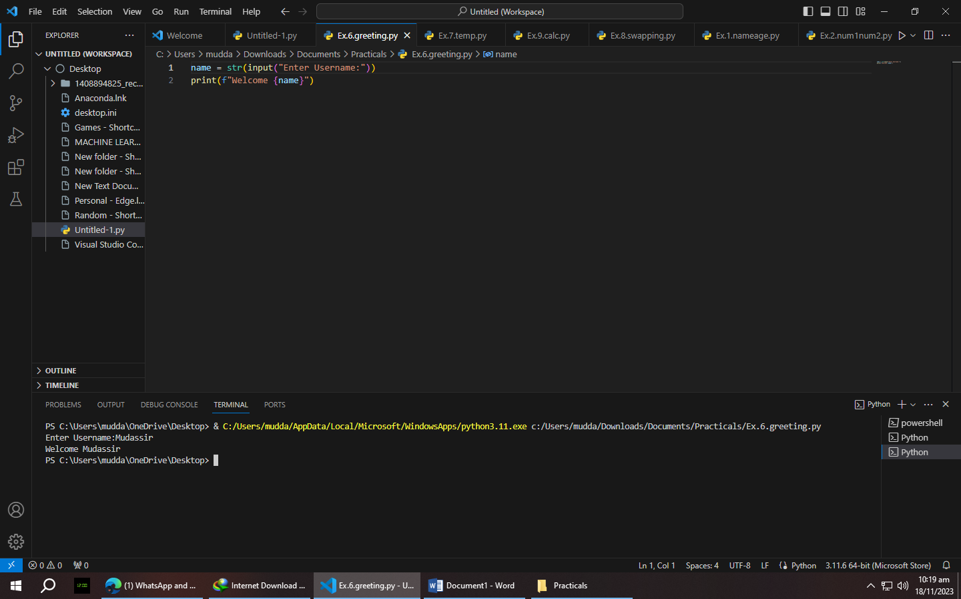

Exercise 7 : Temperature Conversion

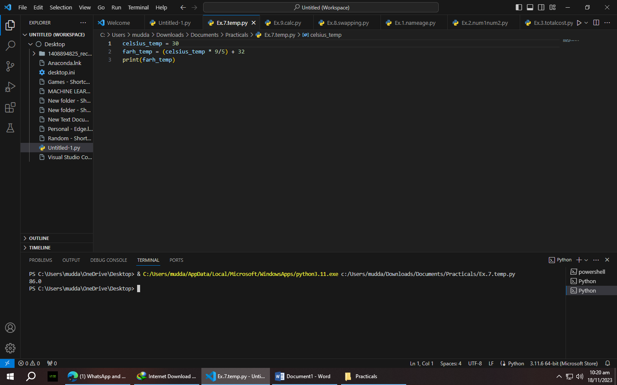

Exercise 8 : Swapping Variables

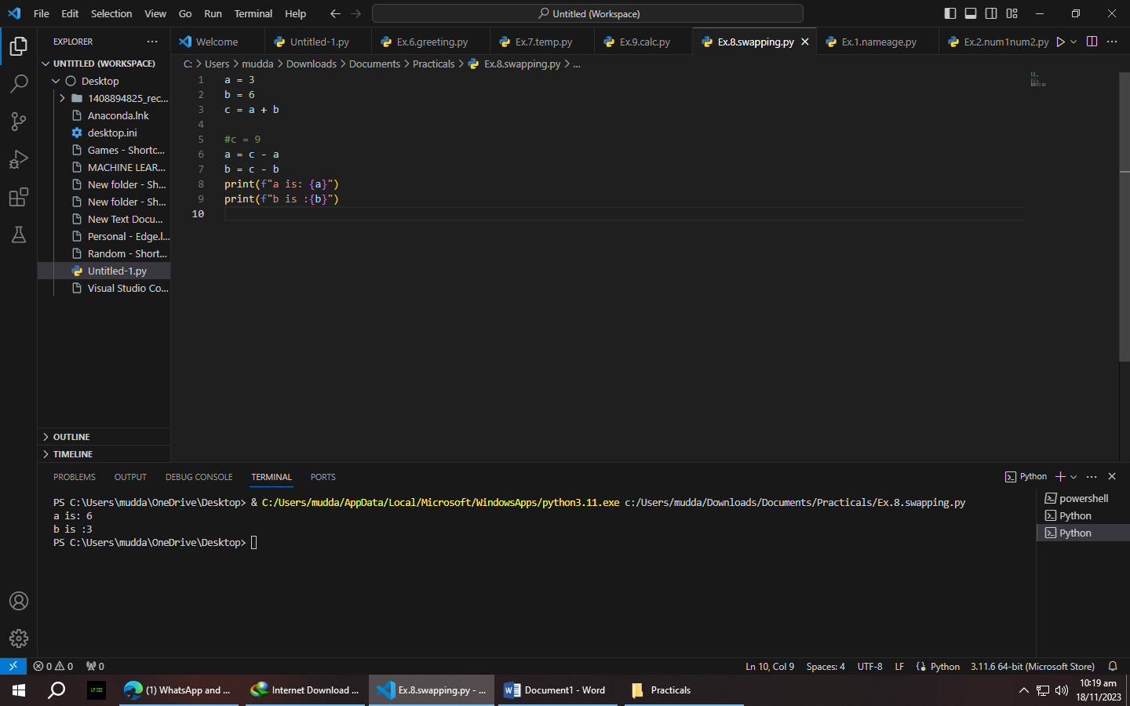

Exercise 9 : Simple Calculator Program

